 | Autumn |  | Spring |  | Summer
Middle School  Year A |  | 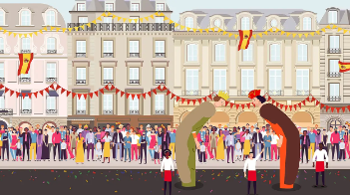  Spanish Greetings with Puppets | 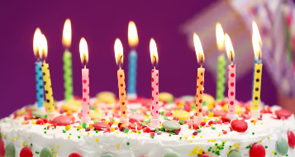  Spanish Numbers and Ages | 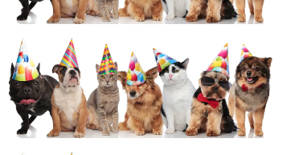  Pets and Colours in Spanish | 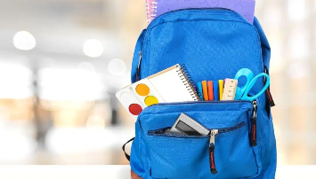  Classroom Objects in Spanish | Consolidation and pen pal project
Middle School Year B |  | 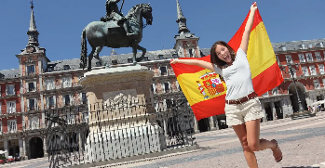  Welcome to Spain | 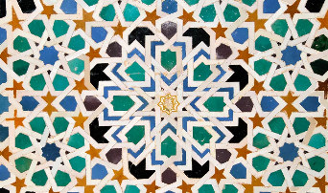  Shapes and Colours in Spanish | 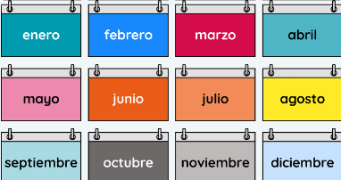  Dates and Birthdays | 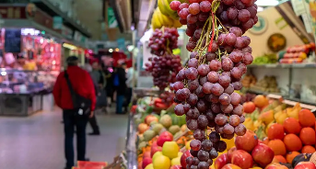  At the Market | Consolidation and pen pal project
Supplementary Year |  | 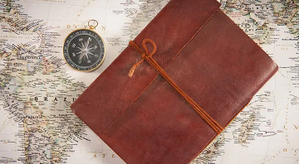  Journey Around Latin America | 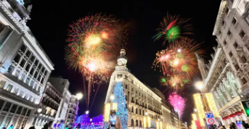  Spanish Celebrations | 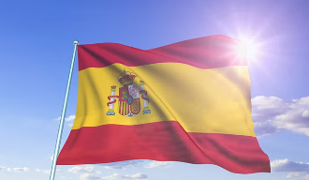  The Weather in Spain | 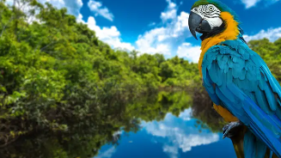  The Amazon Rainforest | Consolidation and pen pal project

 | Autumn |  | Spring |  | Summer
Upper School  Year A |  | 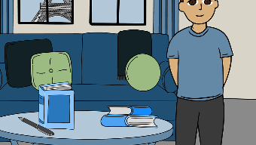  Describing Family and Friends in Spanish | 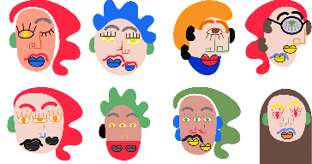  Spanish Portraits | 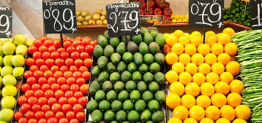  Shopping in Spain |   Household Tasks in Spanish | Consolidation and pen pal project
Upper School Year B |  | 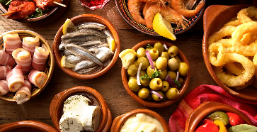  Favourite Foods in Spanish | 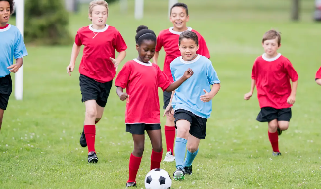  Sports in Spanish | 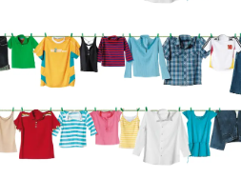  Clothes in Spanish | 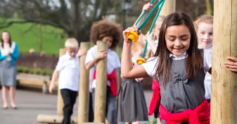  School Life in Spanish | Consolidation and pen pal project
Supplementary Year |  | 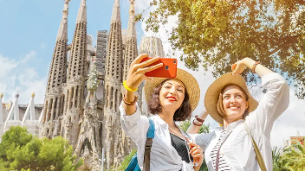  A Trip Across Spain | 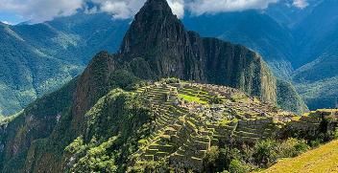  Saving South America | 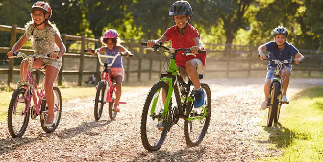  Free Time in Spain | 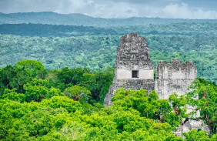  Maya City Treasure Hunt | Consolidation and pen pal project

