 | Autumn | Spring | Summer
Lower School Year A | 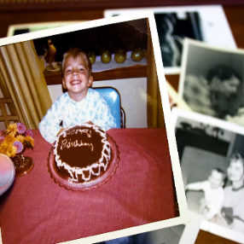  How am I making history? | How have toys changed through time?  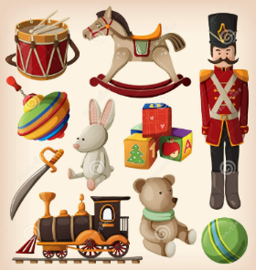 | What do we know about the Great Fire of London?  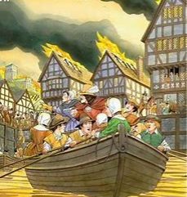
EYFS Year A | Know some similarities and differences between things in the past and now, drawing on their experiences and what has been read in class. | Understand the past through settings, characters and events encountered in books read in class and storytelling. | Talk about the lives of the people around them and their roles in society.
Lower School Year B | 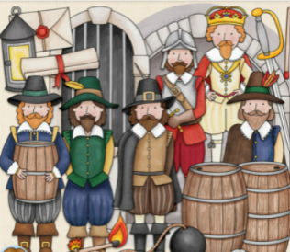  Who was Guy Fawkes? | Who inspires us?  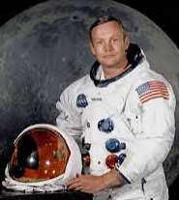  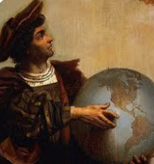 | Which women have changed the world?  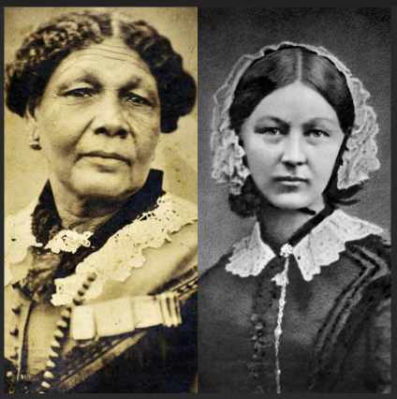
EYFS Year B | Understand the past through settings, characters and events encountered in books read in class and storytelling. | Know some similarities and differences between things in the past and now, drawing on their experiences and what has been read in class. | Talk about the lives of the people around them and their roles in society.

 | Autumn | Spring | Summer
Middle School  Year A  British History | What was it like in the Stone Age and Iron Age?  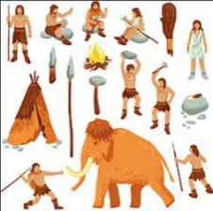 | What happened in Roman Britain and why?  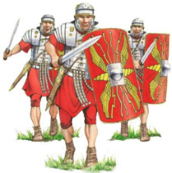 | What happened between the Anglo Saxons and Vikings and why?  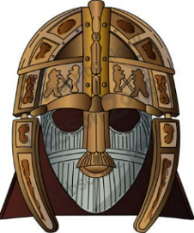
Key concepts | Settlements and Homes | Empire | Beliefs
Middle School Year B  Ancient Civilisations | What were the beliefs of Ancient Egyptians?  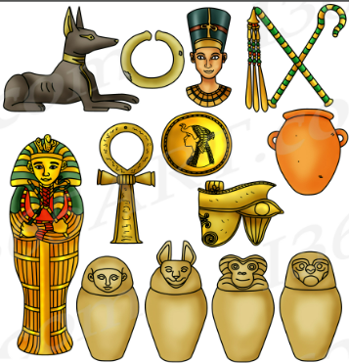 | How has Ancient Greece influenced our lives today?  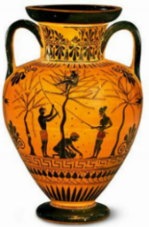 | What was the Mayan Empire?  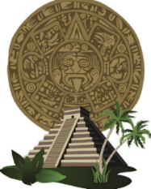
Key concepts | Beliefs | Leadership and Power | Settlements and Homes
Supplementary Year  British History | How have the Victorians and the Industrial Revolution changed British history?  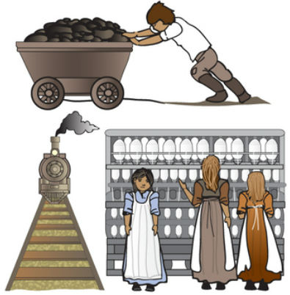 | How have children’s lives changed?  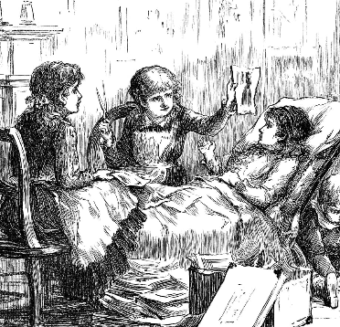 | How has crime and punishment changed over time?  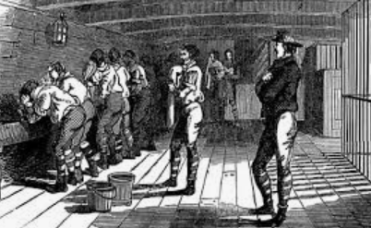
Key concepts | Leadership and Power | Empire | Settlements and Homes

 | Autumn | Spring | Summer
Upper School  Year A  British History | Who were the Vikings and how should we remember them?  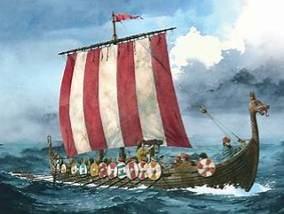 | From Henry VIII to Queen Victoria - What can we learn about British monarchs?  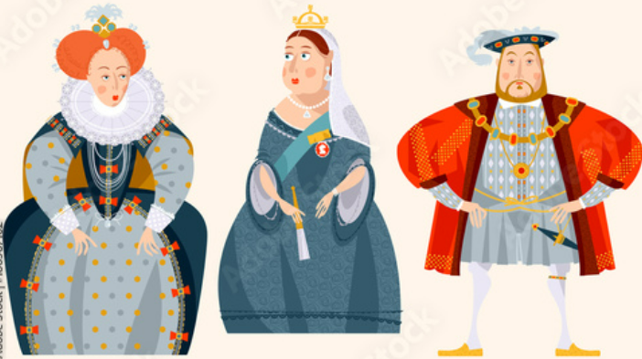 | What happened in World War II in Salcombe and beyond?  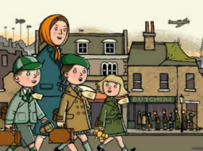
Key concepts | Beliefs | Leadership and Power | Settlements and Homes
Upper School Year B  Ancient Civilisations | What are the Benin Bronzes and why are they significant?  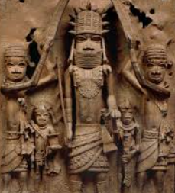 | What was The Shang Dynasty?  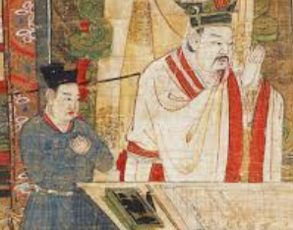 | What was Ancient Baghdad like and why was it important?  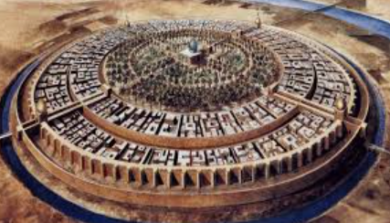
Key concepts | Beliefs | Settlements and Homes | Empire
Supplementary Year  British History | How have the Victorians and the Industrial Revolution changed British history? | How have children’s lives changed? | How has crime and punishment changed over time?
Key concepts |  | Empire | Settlements and Homes

Knowledge and Skills: Lower School Year A
How am I making history? |  | How have toys changed through time? |  | What do we know about the Great Fire of London?
EYFS CURRICULUM COVERAGE:  Know some similarities and differences between things in the past and now, drawing on their experiences and what has been read in class. | NATIONAL CURRICULUM COVERAGE:  KS1 – Changes in living memory | EYFS CURRICULUM COVERAGE:  Understand the past through settings, characters and events encountered in books read in class and storytelling. | NATIONAL CURRICULUM COVERAGE:  KS1 - The lives of significant individuals in the past who have contributed to national and international achievements | EYFS CURRICULUM COVERAGE:  Talk about the lives of the people around them and their roles in society. | NATIONAL CURRICULUM COVERAGE:  KS1 – Events beyond living memory that are significant nationally or globally
KS1 SUBSTANTIVE KNOWLEDGE:  I KNOW that the past is events that have already happened.  I KNOW that ‘the present’ is time happening now.  I KNOW that some people and events are considered more ‘special’ or significant than others. |  | KS1 SUBSTANTIVE KNOWLEDGE:  I KNOW what our toys are like today (materials made of; typical examples;where bought from).  I KNOW what our parents’ and grandparents’ toys were like, and how they are different and similar to our own.  I KNOW some ways in which toys have changed over time. |  | KS1 SUBSTANTIVE KNOWLEDGE:  I KNOW how the Great Fire of London started.  I KNOW what happened during the Great Fire of London and why so many buildings burnt down.
KS1 DISCIPLINARY KNOWLEDGE:  I KNOW THAT we remember some but not all of the events we live through. ((Interpretations of History)  I KNOW THAT the past can be represented in photographs (Interpretations of History) |  | KS1 DISCIPLINARY KNOWLEDGE:  I KNOW HOW TO match objects to people of different ages. (Chronological Understanding)  I KNOW THAT adults talking about their memories of the past may not be reliable. (Interpretations of History) |  | KS1 DISCIPLINARY KNOWLEDGE:  I KNOW HOW TO communicate my knowledge through making models. (Organisation and Communication)  I KNOW HOW TO recount stories from the past. (Range and Depth of Historical Knowledge)

Knowledge and Skills: Lower School Year B
Who was Guy Fawkes? |  | Who inspires us? |  | Which women have changed the world?
EYFS CURRICULUM COVERAGE:  Understand the past through settings, characters and events encountered in books read in class and storytelling. | NATIONAL CURRICULUM COVERAGE:  KS1 – Events beyond living memory that are significant nationally or globally | EYFS CURRICULUM COVERAGE:  Know some similarities and differences between things in the past and now, drawing on their experiences and what has been read in class. | NATIONAL CURRICULUM COVERAGE:  KS1 - The lives of significant individuals in the past who have contributed to national and international achievements | EYFS CURRICULUM COVERAGE:  Talk about the lives of the people around them and their roles in society. | NATIONAL CURRICULUM COVERAGE:  KS1 - The lives of significant individuals in the past who have contributed to national and international achievements
KS1 SUBSTANTIVE KNOWLEDGE:  I KNOW who Guy Fawkes was and what the Gunpowder Plot was.  I KNOW what went wrong with the Plot and how we know.  I KNOW how we remember Guy Fawkes today. |  | KS1 SUBSTANTIVE KNOWLEDGE:  I KNOW the key events and important events in the life of chosen individuals.  I KNOW why these individuals are remembered and how we know about their lives.  I KNOW ways in which exploring has changed over time. |  | KS1 SUBSTANTIVE KNOWLEDGE:  I KNOW the key events and important events in the life of chosen individuals (eg Florence Nightingale and Mary Seacole; Rosa Parks and Emily Davison).  I KNOW why these individuals are remembered and how we know about their lives.  I KNOW when these individuals were alive (earlier/later).
KS1 DISCIPLINARY KNOWLEDGE:  I KNOW HOW TO recount stories from the past. (Range and Depth of Historical Knowledge)  I KNOW why people did things, why events happened and what happened as a result. (Range and Depth of Historical Knowledge) |  | KS1 DISCIPLINARY KNOWLEDGE:  I KNOW why people did things, why events happened and what happened as a result. (Range/Depth of Historical Knowledge)  I KNOW HOW TO compare pictures or photographs of people or events in the past. (Interpretations of History)  I KNOW HOW TO communicate my knowledge through drama and role-play (Organisation & Communication) |  | KS1 DISCIPLINARY KNOWLEDGE:  I KNOW HOW TO use a source to answer questions about the past on the basis of simple observations. (Historical Enquiry)  I CAN sequence photographs and images from different periods of time. (Chronological Understanding)

Knowledge and Skills: Middle School Year A
What was it like in the Stone Age and Iron Age? | What happened in Roman Britain and why? | What happened between the Anglo Saxons and Vikings and why?
NATIONAL CURRICULUM COVERAGE:  KS2 – Learn about the changes in Britain from the Stone Age to the Iron Age. | NATIONAL CURRICULUM COVERAGE:  KS2 - Learn about the Roman empire and its impact on Britain. | NATIONAL CURRICULUM COVERAGE:  KS2 – Britain’s settlement by Anglo-Saxons and Scots. The Viking and Anglo-Saxon struggle for the Kingdom of England to the time of Edward the Confessor.
SUBSTANTIVE KNOWLEDGE:  I KNOW about the lifestyle of Stone Age man.  I KNOW how and when Stonehenge was built.  I KNOW what life was like in an Iron Age hillfort community. | SUBSTANTIVE KNOWLEDGE:  I KNOW why the Romans invaded Britain.  I KNOW how and why Boudicca stood up to the Romans.  I KNOW how the Romans changed the lives of people living in Britain. | SUBSTANTIVE KNOWLEDGE:  I KNOW why the Anglo-Saxons invaded Britain.  I KNOW how people’s lives changed when Christianity came to Britain.  I KNOW about the life and achievements of Alfred the Great.
KS2 DISCIPLINARY KNOWLEDGE:  I CAN observe small details in artefacts and pictures. (Historical Enquiry)  I CAN choose relevant material to present a picture of one aspect of life in time past. (Historical Enquiry) | KS2 DISCIPLINARY KNOWLEDGE:  I CAN place the time studied and key events from time on a timeline. (Chronological Understanding)  I UNDERSTAND more complex terms eg BC/AD/CE. (Chronological Understanding) | DISCIPLINARY KNOWLEDGE:  I CAN distinguish between different sources, including comparing different versions of the same story. (Interpretations of History)  I CAN link sources and work out how conclusions were arrived at. (Interpretations of History)
KEY CONCEPTS:  Settlements and Homes | KEY CONCEPTS:  Empire | KEY CONCEPTS:  Beliefs

Knowledge and Skills: Middle School Year B
What were the beliefs of Ancient Egyptians? | How has Ancient Greece influenced our lives today? | What was the Mayan Empire?
NATIONAL CURRICULUM COVERAGE:  KS2 - Learn about the achievements of the earliest civilizations – and a depth study of Ancient Egypt. | NATIONAL CURRICULUM COVERAGE:  KS2 – Learn about Ancient Greece – a study of Greek life and achievements and their influence on the western world. | NATIONAL CURRICULUM COVERAGE:  KS2 – Learn about a non-European society that contrasts with British history –a study of Mayan civilization c. AD 900.
SUBSTANTIVE KNOWLEDGE:  I KNOW that Ancient Egypt was over 5000 years ago.  I KNOW what everyday life was like in Ancient Egypt for men, women and children.  I KNOW what Ancient Egyptians believed about life after death, and how their beliefs affected their lives. | SUBSTANTIVE KNOWLEDGE:  I KNOW what everyday life was like in Ancient Athens.  I KNOW that democracy was a key development of Ancient Greece.  I KNOW different ways in which Ancient Greeks influenced our lives today. | SUBSTANTIVE KNOWLEDGE:  I KNOW what life was like at the height of the Mayan civilisation.  I KNOW some reasons why the Mayan empire grew.  I KNOW some explanations for why the Mayan empire ended so quickly.
KS2 DISCIPLINARY KNOWLEDGE:  I CAN find out about everyday lives of people in time studied, and compare with our life today. (Range and Depth of Historical Knowledge)  I CAN recognise primary and secondary sources. (Historical Enquiry)  I CAN use the internet for research with increasing confidence. (Historical Enquiry) | KS2 DISCIPLINARY KNOWLEDGE:  I CAN communicate my knowledge and understanding through oral presentation, making appropriate use of dates and terms. (Organisation and Communication) | DISCIPLINARY KNOWLEDGE:  I CAN place current study on timeline in relation to other studies. (Chronological Understanding)  I UNDERSTAND that different evidence will lead to different conclusions. (Interpretations of History)  I CAN select and organise information to produce structured written work, making appropriate use of dates and terms. (Organisation and Communication)
KEY CONCEPTS:  Beliefs | KEY CONCEPTS:  Leadership and Power | KEY CONCEPTS:  Settlement and Homes

Knowledge and Skills: Upper School Year A
Who were the Vikings and how should we remember them? | From Henry VIII to Queen Victoria - What can we learn about British monarchs? | What happened in World War II in Salcombe and beyond?
NATIONAL CURRICULUM COVERAGE:  The Viking and Anglo-Saxon struggle for the Kingdom of England to the time of Edward the Confessor. | NATIONAL CURRICULUM COVERAGE:  A study of an aspect or theme in British history that extends pupils’ chronological knowledge beyond 1066 (changes in an aspect of social history, such as the changing role of the monarch from Tudor times) | NATIONAL CURRICULUM COVERAGE:  KS2 - A local history study (i.e. impact on Exeter)  Study an aspect or theme in British history that extends pupils’ chronological knowledge beyond 1066, through exploring a significant turning point in British history: World War II and the Battle of Britain.
SUBSTANTIVE KNOWLEDGE:  I KNOW why the Vikings tried to take control of Britain, and the struggle they had with Anglo-Saxons.  I KNOW some of the key beliefs of Viking people.  I KNOW about Viking settlements. | SUBSTANTIVE KNOWLEDGE:  I KNOW some key facts about the lives of Henry VIII, Elizabeth I and Victoria.  I KNOW how different monarchs influenced society at that time.  I KNOW how portraits of monarchs use symbols to give messages. | SUBSTANTIVE KNOWLEDGE:  I KNOW why Britain went to war in 1939.  I KNOW how Britain stood strong against the German threat.  I KNOW what life was like on the Home Front.  I KNOW why children were evacuated and what evacuation was like.  I KNOW how World War II impacted my local area.
DISCIPLINARY KNOWLEDGE:  I KNOW HOW TO place current study on a timeline in relation to other studies. (Chronological Understanding)  I KNOW HOW TO link sources and work out how conclusions were arrived at. (Interpretations of History) | DISCIPLINARY KNOWLEDGE:  I KNOW HOW TO compare an aspect of life with the same aspect in another period. (Range and Depth of Historical Knowledge)  I CAN recognise primary and secondary sources. (Historical Enquiry)  I CAN select and organise information to produce structured written work, making appropriate use of dates and terms. (Organisation and Communication) | KS2 DISCIPLINARY KNOWLEDGE:  I CAN identify reasons for and results of people's actions. (Range and Depth of Historical Knowledge)  I CAN examine causes and results of key events and the impact on people. (Range & Depth of Knowledge)  I CAN identify and give reasons for different ways in which the past is represented. (Interpretations of History)
KEY CONCEPTS:  Beliefs | KEY CONCEPTS:  Leadership and Power | KEY CONCEPTS:  Leadership and Power
Knowledge and Skills: Upper School Year B
What are the Benin Bronzes and why are they significant? | What was The Shang Dynasty? | What was Ancient Baghdad like and why was it important?
NATIONAL CURRICULUM COVERAGE:  KS2 - a non-European society that provides contrasts with British history – one study chosen from: Benin (West Africa) c. AD 900-1300 | NATIONAL CURRICULUM COVERAGE:  KS2 – The achievements of the earliest civilizations – an overview of where and when the first civilizations appeared and a depth study of one of the following: The Shang Dynasty of Ancient China | NATIONAL CURRICULUM COVERAGE:  KS2 - A non-European society that provides contrasts with British history – one study chosen from: early Islamic civilization, including a study of Baghdad c. AD 900.
SUBSTANTIVE KNOWLEDGE:  I KNOW where the Kingdom of Benin was located and how it was first established.  I KNOW what the people of Benin Kingdom believed.  I KNOW about the rulers of Benin Kingdom and the Benin Bronzes. | SUBSTANTIVE KNOWLEDGE:  I KNOW where the Shang Dynasty existed and how Shang cities were organised.  I KNOW the religious beliefs of the Shang Dynasty.  I KNOW what the rulers of the Shang Dynasty were like. | SUBSTANTIVE KNOWLEDGE:  I KNOW where Baghdad is in the world and when it’s ‘Golden Age’ fell in history.  I KNOW the importance of the prophet Mohammed to Islamic civilisations.  I KNOW about everyday life during the golden age of Baghdad, including jobs and education.
DISCIPLINARY KNOWLEDGE:  I KNOW HOW TO place current study on a timeline in relation to other studies. (Chronological Understanding)  I KNOW HOW TO link sources and work out how conclusions were arrived at. (Interpretations of History) | KS2 DISCIPLINARY KNOWLEDGE:  I KNOW and sequence key events of the time studied. (Chronological Understanding)  I CAN place current study on timeline in relation to other studies. (Chronological Understanding)  I CAN examine causes and results of key events and the impact on people. (Range & Depth of Knowledge) | KS2 DISCIPLINARY KNOWLEDGE:  I CAN identify reasons for and results of people's actions. (Range and Depth of Historical Knowledge)  I CAN identify and give reasons for different ways in which the past is represented. (Interpretations of History)
KEY CONCEPTS:  Beliefs | KEY CONCEPTS:  Settlements and Homes | KEY CONCEPTS:  Leadership and Power

Knowledge and Skills: Supplementary Year
How have the Victorians and the Industrial Revolution changed British history? | How have children’s lives changed? | How has crime and punishment changed over time?
NATIONAL CURRICULUM COVERAGE:  KS2 – Study an aspect or theme in British history that extends pupils’ chronological knowledge beyond 1066, by exploring a significant turning point in British history, for example, the first railways and the Industrial Revolution. | NATIONAL CURRICULUM COVERAGE:  KS2 – Study an aspect or theme in British history that extends pupils’ chronological knowledge beyond 1066 (changes in an aspect of social history). | NATIONAL CURRICULUM COVERAGE:  KS2 – Study of an aspect or theme in British history that extends pupils’ chronological knowledge beyond 1066 (changes in an aspect of social history).
SUBSTANTIVE KNOWLEDGE:  I KNOW the main changes that took place during Victoria’s reign.  I KNOW how town life and countryside life were different in Victorian times.  I KNOW the main changes in transport during the Industrial Revolution. | SUBSTANTIVE KNOWLEDGE:  I KNOW why children working in Tudor and Victorian times, and what it was like.  I KNOW how and why children’s leisure time has changed over time.  I KNOW different diseases children have caught over time and how they were treated. | SUBSTANTIVE KNOWLEDGE:  I KNOW about Roman and Anglo-Saxon laws and justice.  I KNOW how the Tudors punished criminals.  I KNOW what a Highwayman was and how they can be seen as heroes or villains.  I KNOW how what Victorian prisons were like.
DISCIPLINARY KNOWLEDGE:  I KNOW and sequence key events of the time studied. (Chronological Understanding)  I CAN place current study on timeline in relation to other studies. (Chronological Understanding)  I CAN examine causes and results of key events and the impact on people. (Range & Depth of Knowledge) | DISCIPLINARY KNOWLEDGE:  I KNOW and sequence key events of the time studied. (Chronological Understanding)  I CAN place current study on timeline in relation to other studies. (Chronological Understanding)  I CAN examine causes and results of key events and the impact on people. (Range & Depth of Knowledge) | DISCIPLINARY KNOWLEDGE:  I CAN place the time studied and key events from time on a timeline. (Chronological Understanding)  I CAN compare an aspect of life with the same aspect in another period. (Range and Depth of Historical Understanding)  I CAN identify and give reasons for different ways in which the past is represented. (Interpretations of History)
KEY CONCEPTS:  Settlements and Homes | KEY CONCEPTS:  Leadership and Power | KEY CONCEPTS:  Leadership and Power

Progression by Disciplinary Knowledge
 | Lower School | Middle School | Upper School
Chronological understanding | - I can remember and talk about significant experiences in my own life.  - I can order photographs of people’s lives. | - I can match objects to people of different ages.  - I can sequence photographs and images from different periods of time. | - I can place the time studied and key events from time on a timeline.  - I understand more complex terms eg BC/AD/CE.  - I know and sequence key events of the time studied.  - I can place current study on timeline in relation to other studies.
Range and depth of  historical knowledge | - I know some similarities and differences between things in the past and now. | - I know and can recount stories about the past.  - I recognise why people did things, why events happened and what happened as a result. | - I can find out about everyday lives of people in time studied, and compare with our life today.  - I can identify reasons for and results of people's actions.  - I can examine causes and results of key events and the impact on people.  - I can compare an aspect of life with the same aspect in another period.
Interpretations of history | - I can understand the past through settings, characters and events in stories. | - I know that adults talking about their memories may not always be reliable.  - I can compare pictures or photographs of people or events in the past. | - I can identify and give reasons for different ways in which the past is represented.  - I can distinguish between different sources, including comparing different versions of the same story.  - I can link sources and work out how conclusions were arrived at.  - I am aware that different evidence will lead to different conclusions.
Historical enquiry | - I can listen attentively and respond to stories and discussions about the past with relevant questions, comments and actions. | - I can find answers to simple questions about the past from sources of information.  - I can use a source to answer questions about the past on the basis of simple observations. | - I can observe small details in artefacts and pictures.  - I can choose relevant material to present a picture of one aspect of life in time past.  - I can recognise primary and secondary sources.  - I can use the internet for research with increasing confidence.
Organisation & communication | - I can express my ideas and feelings about my experiences using full sentences, including use of past, present and future tenses, with modelling and support from my teacher. | - I can communicate my knowledge through drawing pictures and making models.  - I can communicate my knowledge through drama/role play and writing. | - I can communicate my knowledge and understanding through oral presentation and writing.  - I can select and organise information to produce oral presentations and structured written work, making appropriate use of dates and terms.

History for learners with SEND
Inclusion in history means: setting suitable learning challenges, responding to pupils’ diverse needs, and overcoming potential barriers to learning and assessment for individuals and groups.
Possible struggle or challenge | Scaffold or support to consider
- Difficulties with reading | - Consider placing key sources and information on audio/MP3, so that pupils who struggle with reading can at least listen, perhaps with the text also in front of them. Use of Talking Tins at KS1. Pairing of confident and less confident readers when considering groupings in history.  - Use audio/visual representations of ideas when possible to make information available to all. Pictures/drawings/recordings/video clips can be used to generate pupil-to-pupil discussion or precede written information. Use or present information in tables or diagrams, rather than unbroken text.  - Make use of fluency strategies from reading lessons when reading historical information – including echo reading and choral reading.
- Difficulties with language/ vocabulary | - Provide a word bank related to the theme. This could be provided before the start of the unit, as pre-teaching, or built up cumulatively throughout the sequence of lessons.  - Provide sentence stems/speaking frames for oracy/discussion tasks to structure spoken language.  - Modelling connectives verbally to help prompt elaboration, eg ‘and so’ to help pupils link information, ‘because’ to encourage pupils to give reasons, or ‘consequently’ to prompt pupils to think of the results of actions.  - Recognise that the language of history may be challenging and cause barriers for some pupils, including the specific use in history of an everyday word, eg ‘party’, ‘state’ ; the use of history-specific terms, eg ‘chronological’, ‘artefact’ ; the use of abstract terms, eg ‘power’, ‘belief’. Plan to teach new history vocabulary explicitly in context using activities from the menu of instructional activities.  - Use pictures and symbols (eg Widgit) to illustrate abstract, new or historical concepts.
- Difficulties with writing/ recording | - Provide structured writing frames including, for example, key vocabulary, sentence stems, cloze procedure/missing word structures.  - Consider alternatives to recording eg ICT (however, remember that sometimes pupils can be distracted by all the different possibilities of adding graphics, sound, animation etc.)
- Difficulties with maths/number | - Be aware of this potentially being a barrier in chronology/timeline work. Ask children to sort (eg old/new) or sequence images/photos (with dates removed).  - Horizontal rather than vertical time lines should be used as these appear to cause less confusion than spiral helixes or ‘zig-zag’ lines. It is important from the outset to represent centuries distinctly on the time line. This can be done effectively by colour coding dates.
- Difficulties with memory/ processing | - Adapt tasks to allow for slow release of information e.g. sequencing just the first steps in an event, or the first 4 cards for a timeline and then adding 2 more to build confidence and avoid overwhelming pupils at the start. It is easier to add more detail than to unscramble confusion.  - Reinforcement of key facts/dates/names etc. through retrieval practice principles – revisit regularly, spaced practice, dual coding (words and visuals together).  - Reduce reliance on memory by using a chart that shows the ‘big picture’ to help pupils make links between lessons, eg a chart showing the big question, and how each lesson is related to the question. Use mind maps and other visual devices to help pupils see patterns and relationships.  - Narrative can help all pupils, including those with learning difficulties, to make sense of events by bringing the past to life, so consider using stories (either of real or imagined people) within history learning.  - When questioning, allow pupils time to discuss the answers to questions in pairs, before requesting verbal responses. Structures such as think-pair-share can be really helpful.  - When you are asking questions, use pupils’ names to warn them that they are about to be involved. Sometimes, warning pupils quietly that you are about to ask them a question gives them a little thinking time and they may be able to answer more confidently.
- Difficulties with engagement, for example because of SEMH needs | - Use motivational initial stimuli to engage pupils in a history activity, eg mysteries, storytelling, visual puzzles.  - Pupils may feel comfortable with their knowledge of their own world but disorientated by ideas associated with the past. Starting with the known allows pupils to feel confident and new ideas to be shaped and modified. Build on pupils’ understanding. Start with pupils’ own knowledge, views and understanding and identify their preconceptions and misconceptions.  - Allow a choice of outcomes to meet the same objective so pupils can choose the form − eg for a piece of work about the Great Fire of London, pupils might produce/complete a: labelled map, storyboard, role-play, audio recording, electronic presentation, or cloze worksheet.  - Include activities with active involvement eg kinaesthetic activities. Examples would be pupils creating human timelines, acting out scenes from a story, asking pupils to stand at the front holding sequencing cards, use of real artefacts. Sorting, matching, underlining, grouping, selecting etc. can all be used in place of written worksheets/copying information.  - Try to provide a real purpose or audience for activities, eg turning the classroom into a museum for another class or parents to visit. Key Stage History provides lots of ideas of activities or outcomes with a purpose or audience, eg help the hapless embalmer.  - Share or discuss careers that can involve historical knowledge – eg archaeologist, production assistant, tour guide, as well as how historical skills (eg communication, critical thinking, making comparisons) are useful for all learning and jobs.

