 | Autumn | Spring | Summer
Lower School Year A | Portraits – Kapow  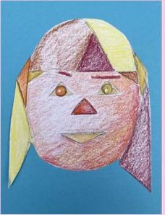 | Playful Making  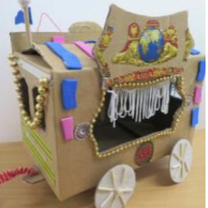 | Simple Printmaking  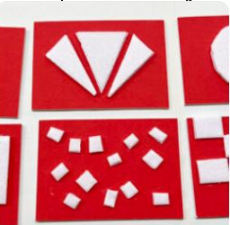
EYFS Year A | - Safely use and explore a variety of materials, tools and techniques, experimenting with form and design.  • Share their creations, explaining the process they have used. | - Safely use and explore a variety of materials, tools and techniques, experimenting with function and texture.  • Share their creations, explaining the process they have used. | - Safely use and explore a variety of materials, tools and techniques, experimenting with colour and design.  • Share their creations, explaining the process they have used.
Lower School Year B | Spirals  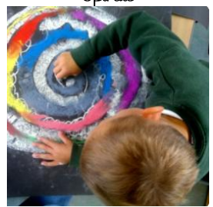 | Expressive Painting  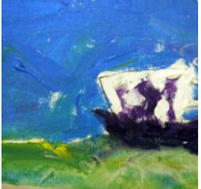 | Be an Architect  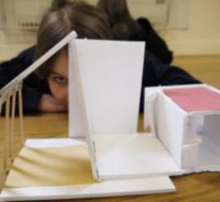
EYFS Year B | - Safely use and explore a variety of materials, tools and techniques, experimenting with colour and form.  • Share their creations, explaining the process they have used. | - Safely use and explore a variety of materials, tools and techniques, experimenting with colour and texture.  • Share their creations, explaining the process they have used. | - Safely use and explore a variety of materials, tools and techniques, experimenting with design and function.  • Share their creations, explaining the process they have used.

 | Autumn | Spring | Summer
Middle School  Year A | Gestural Drawing with Charcoal  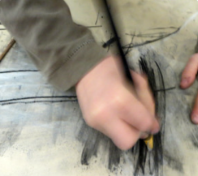 | Exploring the World through Mono Print  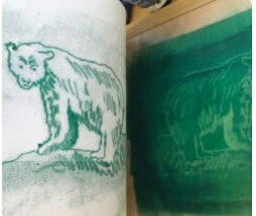 | Stick Transformation Project  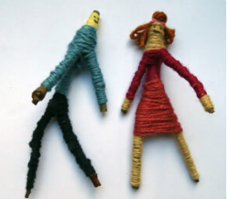
Middle School Year B | Exploring Watercolour  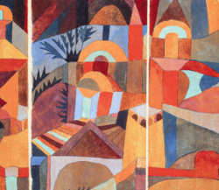 | Explore and Draw  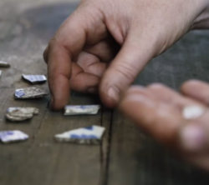 | Making Birds  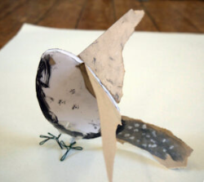
Supplementary Year | Mixed Media Land and City Scapes  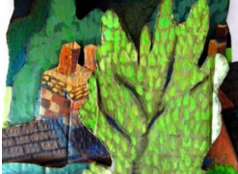 | Shadow Puppets  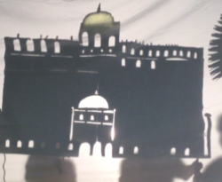 | Storytelling through Drawing  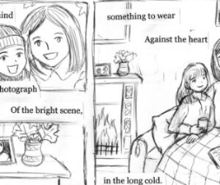

 | Autumn | Spring | Summer
Upper School  Year A | 2D drawing to 3D making  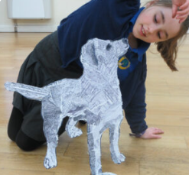 | Working with shape and colour  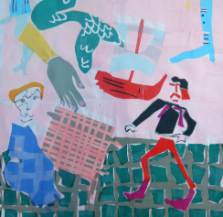 | Festival Feasts  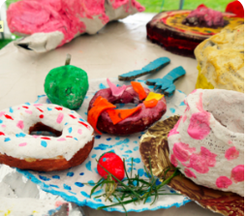
Upper School Year B | Typography and Maps  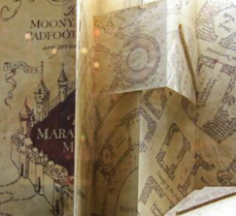 | Exploring Still Life  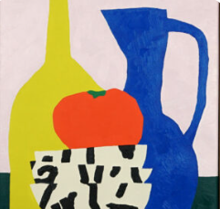 | The Art of Display  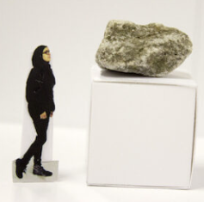
Supplementary Year | Mixed Media Land and City Scapes | Shadow Puppets | Storytelling through Drawing

Knowledge and Skills: Lower School Year A
Portraits |  | Playful Making |  | Simple Printmaking
EYFS CURRICULUM COVERAGE:  - Safely use and explore a variety of materials, tools and techniques, experimenting with form and design.  - Share their creations, explaining the process they have used. | NATIONAL CURRICULUM COVERAGE:  KS1 – Use drawing to develop and share ideas, experiences and imagination.  KS1 – Know about the work of a range of artists, making links to their own work. | EYFS CURRICULUM COVERAGE:  - Safely use and explore a variety of materials, tools and techniques, experimenting with function and texture.  - Share their creations, explaining the process they have used. | NATIONAL CURRICULUM COVERAGE:  KS1 – Use a range of materials creatively to design and make products  KS1 – Use sculpture to develop and share their ideas, experiences and imagination. | EYFS CURRICULUM COVERAGE:  - Safely use and explore a variety of materials, tools and techniques, experimenting with colour and design.  - Share their creations, explaining the process they have used. | NATIONAL CURRICULUM COVERAGE:  KS1 – Use printmaking to develop and share ideas, experiences and imagination.  KS1 – Develop a wide range of techniques in using colour and pattern.
KS1 SUBSTANTIVE KNOWLEDGE:  I CAN draw different lines by varying control and pressure (eg straight, wavy, zigzags, broken, lighter, darker)  I CAN draw and combine geometric shapes.  I CAN recognise that applying more pressure when drawing or colouring gives a darker tone.  I CAN demonstrate a growing spatial awareness to represent the position and size of objects. |  | KS1 SUBSTANTIVE KNOWLEDGE:  I KNOW what we mean by ‘sculpture’ and I know what I like about different pieces of sculpture.  I CAN use my hands to make small sculptures out of lots of different materials.  I CAN bend, twist, fold, cut and fasten.  I CAN use my hands to make sculptures without designing first (i.e. I can just see what happens if….)  I CAN combine of two or more materials to make a sculpture. |  | KS1 SUBSTANTIVE KNOWLEDGE:  I CAN make simple prints using my hands and feet.  I CAN take rubbings of textures in my environment.  I CAN push objects I find into plasticine and make prints.  I CAN cut shapes out of foam board and stick them on a block to make prints from.  I CAN draw into the surface of a foam board and print from that.  I CAN create a symmetrical or sequenced print.
KS1 DISCIPLINARY KNOWLEDGE:  I KNOW that an artist is someone who creates.  I CAN present my own artwork, reflecting and sharing verbally (e.g. “I enjoyed……This went well”) |  | KS1 DISCIPLINARY KNOWLEDGE:  I KNOW that sometimes working with materials is hard work – things break or my fingers hurt – but that is all ok  I CAN document my work by taking a photograph.  I KNOW HOW TO work in a playful, exploratory way. |  | KS1 DISCIPLINARY KNOWLEDGE:  I CAN use my sketchbook to test out different ideas.  I CAN explore concepts like ‘repeat’, ‘pattern’ and ‘sequencing’.  I CAN share responses to my classmates’ work, pointing out  similarities and differences.
Knowledge and Skills: Lower School Year B
Spirals |  | Expressive Painting |  | Be an Architect
EYFS CURRICULUM COVERAGE:  - Safely use and explore a variety of materials, tools and techniques, experimenting with colour and form.  - Share their creations, explaining the process they have used. | NATIONAL CURRICULUM COVERAGE:  KS1 – Use drawing to develop and share ideas, experiences and imagination.  KS1 – Develop a wide range of techniques in using line and shape. | EYFS CURRICULUM COVERAGE:  - Safely use and explore a variety of materials, tools and techniques, experimenting with colour and texture.  - Share their creations, explaining the process they have used. | NATIONAL CURRICULUM COVERAGE:  KS1 – Learn about a range of artists, making links to their own work.  KS1 – Develop a wide range of techniques in using colour and texture. | EYFS CURRICULUM COVERAGE:  - Safely use and explore a variety of materials, tools and techniques, experimenting with design and structure.  - Share their creations, explaining the process they have used. | NATIONAL CURRICULUM COVERAGE:  KS1 - Develop art and design techniques in using form and space.  KS1 – Learn about a range of designers, making links to their own work.
KS1 SUBSTANTIVE KNOWLEDGE:  I KNOW HOW TO draw using a continuous line.  I CAN explore lines by moving my fingers, wrist, elbow and shoulder.  I CAN make an observational drawing.  I CAN make different marks with different drawing tools (including pastels and chalks).  I CAN make choices about the colours I use in my work. |  | KS1 SUBSTANTIVE KNOWLEDGE:  I KNOW how primary colours mix to make secondary colours.  I KNOW that I can change the hue of a secondary colour by changing the amount of the primary colours used.  I CAN mix secondary colours and experiment with hues.  I CAN make a loose drawing from still life, focusing on colours and shapes.  I KNOW some features of the artwork of Van Gogh and Cezanne. |  | KS1 SUBSTANTIVE KNOWLEDGE:  I KNOW that architects design buildings.  I CAN share how architecture makes me feel, what I like and what I think is interesting.  I CAN explore line and shape through drawings of architecture.  I CAN make an architectural model of a building, thinking about form, structure and balance.  I CAN reshape materials and fasten them together to make a model.
KS1 DISCIPLINARY KNOWLEDGE:  I KNOW HOW TO use my sketchbook to practice observational drawing.  I CAN reflect on an artist’s work and share my response verbally.  I CAN present my own artwork, reflecting and sharing verbally (e.g. “I enjoyed……This went well”) |  | KS1 DISCIPLINARY KNOWLEDGE:  I CAN present my own artwork, reflecting and sharing verbally (e.g. “I enjoyed……This went well”)  I CAN share responses to classmates’ work, appreciating similarities and differences. |  | KS1 DISCIPLINARY KNOWLEDGE:  I KNOW that sometimes working with materials is hard work – things break or my fingers hurt – but that is all ok  I KNOW HOW TO document my work by taking a  photograph.  I KNOW HOW TO work in a playful, exploratory way.
Knowledge and Skills: Middle School Year A
Gestural Drawing with Charcoal | Exploring the World through Mono Print | Stick Transformation Project
NATIONAL CURRICULUM COVERAGE:  KS2 – Improve mastery of art and design techniques, including drawing with charcoal.  KS2 - Create sketch books to record their observations and use them to review and revisit ideas | NATIONAL CURRICULUM COVERAGE:  KS1 – Develop a wide range of techniques in using form and shape.  KS2 – Learn about great artists and designers in history. | NATIONAL CURRICULUM COVERAGE:  KS1 – Develop a wide range of techniques in using texture and shape.  KS2 – Improve mastery of art and design techniques, including sculpture with a range of materials.
SUBSTANTIVE KNOWLEDGE:  I KNOW how artists (including Edward Degas) use charcoal in their work.  I KNOW how to make different types of mark with charcoal, using my hands as well as the charcoal.  I CAN use light and dark tones in my work.  I KNOW what Chiaroscuro is and how I can use it in my work. | SUBSTANTIVE KNOWLEDGE:  I CAN make drawings using photos from films as my source material.  I CAN make drawings using soft pencil or handwriting pen.  I CAN look closely at small objects close to me and make drawings with soft pencil or handwriting pen at the same scale or size.  I KNOW what a mono print is and have explored the work of an artist who uses mono print.  I CAN use carbon paper to make mono prints linked to a theme. | SUBSTANTIVE KNOWLEDGE:  I CAN take a familiar object like a stick, and use my imagination to think about what it might become.  I CAN use my sketchbook to generate ideas and to test ideas.  I CAN use a variety of materials to transform my object thinking about form and colour.  I CAN cut materials with simple tools and fasten materials together to construct my sculpture.
KS2 DISCIPLINARY KNOWLEDGE:  I CAN reflect on an artist’s work and share my response verbally (“I liked…..I didn’t understand….”)  I CAN share my sketchbook with the class. | KS2 DISCIPLINARY KNOWLEDGE:  I CAN listen to others talking about their work, and sometimes I can add my thoughts.  I CAN share my thoughts on an artist’s work. | DISCIPLINARY KNOWLEDGE:  I CAN share my sketchbook and sculpture with the class and talk about how I made it and what I liked.  I CAN listen to my classmates feedback about my work.

Knowledge and Skills: Middle School Year B
Exploring Watercolour | Explore and Draw | Making Birds
NATIONAL CURRICULUM COVERAGE:  KS2 – Improve their mastery of art and design techniques, including painting with a range of materials [ie watercolour].  KS1 – Develop a wide range of techniques in using colour.  KS2 – Learn about great artists in history. | NATIONAL CURRICULUM COVERAGE:  KS2 – Create sketchbooks to record their observations and use them to review and revisit ideas.  KS1 – Develop a wide range of techniques in using line, texture and shape. | NATIONAL CURRICULUM COVERAGE:  KS1 – Develop a wide range of techniques in using texture and shape.  KS2 – Improve mastery of art and design techniques, including sculpture with a range of materials.
SUBSTANTIVE KNOWLEDGE:  I CAN explore watercolour and understand the different effects I can achieve.  I CAN discuss other artists who use watercolour and share my thoughts about their work.  I CAN name primary colours and secondary colours, and use these carefully in my artwork. | SUBSTANTIVE KNOWLEDGE:  I KNOW what wax resist is.  I CAN explore line, texture and shape in my drawings.  I CAN make an observational drawing, focusing for 5-10 minutes.  I KNOW HOW TO combine different media, eg wax, watercolour, graphite, water.  I CAN cut separate drawings out and use them to create a new artwork, thinking carefully about composition. | SUBSTANTIVE KNOWLEDGE:  - I CAN look carefully at photos and films, take in the details and overall shapes, and then make drawings of what I have noticed.  - I CAN draw from life, looking closely.  - I CAN use colour in my drawings and mix two or more different media together.  - I CAN fold, tear, crumple and collage paper to transform it from 2d to 3d.  - I CAN use a variety of materials to make my own sculpture, and I have taken on the challenge of making my sculpture balance and stand.
KS2 DISCIPLINARY KNOWLEDGE:  I CAN work without an end goal in mind – letting the paint lead me.  I UNDERSTAND that we all see different things in the artwork we make and we all have a different response to art. | KS2 DISCIPLINARY KNOWLEDGE:  I CAN work with care and focus, enjoying making drawings which are unrushed.  I CAN reflect on an artist’s work and share my response verbally (“I liked….I didn’t understand….”) | DISCIPLINARY KNOWLEDGE:  - I CAN look at the work of other artists and I can share my response to their work.  - I CAN see how all our sculptures are individual.  - I CAN share my work with my classmates and teachers, and consider what was successful for me.
Knowledge and Skills: Upper School Year A
2D drawing to 3D making | Working with shape and colour | Festival Feasts
NATIONAL CURRICULUM COVERAGE:  KS2 – Improve their mastery of art and design techniques, including drawing and sculpture.  KS2 – Create sketchbooks to record observations and use them to review and revisit ideas. | NATIONAL CURRICULUM COVERAGE:  KS2 – Learn about great artists in history.  KS2 - Create sketchbooks to record observations and use them to review and revisit ideas. | NATIONAL CURRICULUM COVERAGE:  KS2 – Improve their mastery of art and design techniques, including drawing and sculpture.  KS2 – Create sketchbooks to record observations and use them to review and revisit ideas.
SUBSTANTIVE KNOWLEDGE:  I CAN explore positive and negative space to draw a simple object.  I KNOW the grid method and how it can help with scaling up an image.  I CAN use line, tone, colour, shape and composition to make my work interesting.  I CAN transform my drawing into a three-dimensional object. | SUBSTANTIVE KNOWLEDGE:  I KNOW about the work of the artist Henri Matisse.  I KNOW what is meant by negative and positive shapes.  I CAN cut shapes directly into paper, using scissors, inspired by the artwork.  I CAN collage with my cut elements, choosing colour, shape and composition to make my own response.  I CAN add to my collage, using line, colour and shape made by stencils. | SUBSTANTIVE KNOWLEDGE:  I KNOW that sculpture will be seen from different viewpoints.  I CAN use my sketchbook to draw food, using a variety of media, using line, shape and colour to capture the texture and form of the food.  I CAN make a sculpture of food considering form and colour, combining lots of materials.  I CAN combine modelling with painting to create a sculpture.
DISCIPLINARY KNOWLEDGE:  I CAN reflect on an artist’s work and share my response verbally (“I liked….It reminded me of….”) | KS2 DISCIPLINARY KNOWLEDGE:  I CAN present my own artwork, reflect and share verbally (“I enjoyed…..This went well…..I would have liked….Next time I might…..”) | KS2 DISCIPLINARY KNOWLEDGE:  I KNOW HOW TO document my work using photographs, considering viewpoint and perspective.  I CAN take creative risks by experimenting to see what happens.

Knowledge and Skills: Upper School Year B
Typography and Maps | Exploring Still Life | The Art of Display
NATIONAL CURRICULUM COVERAGE:  KS2 – Create sketchbooks to record their observations and use them to review and revisit ideas.  KS2 – Improve mastery of art and design techniques, including drawing. | NATIONAL CURRICULUM COVERAGE:  KS2 – Learn about great artists in history.  KS2 – Create sketchbooks to record their observations and use them to review and revisit ideas. | NATIONAL CURRICULUM COVERAGE:  KS2 – Improve their mastery of art and design techniques, including drawing and sculpture.  KS2 – Create sketchbooks to record observations and use them to review and revisit ideas.
SUBSTANTIVE KNOWLEDGE:  I KNOW that typography is the visual art of creating and arranging letters and words to help communicate ideas or emotions.  I CAN create my own letters in a playful way using cutting and collage.  I CAN draw my own letters using pen and pencil inspired by objects I have chosen around me.  I CAN explore line weight, grip and shape, and explore how 2D can become 3D through manipulation of paper. | SUBSTANTIVE KNOWLEDGE:  I KNOW about the work of contemporary and more traditional artists who work within the still life genre.  I CAN use my sketchbook to make visual notes, record and reflect.  I CAN draw from observation and think about how I can use line, colour, shape, texture, form and composition to make my artwork interesting. | SUBSTANTIVE KNOWLEDGE:  I KNOW that some artists choose to display their work on “plinths” and I have understood how the way a work is displayed can affect the way the audience sees the work.  I CAN use my sketchbook to collect ideas about how other artists consider how their work is displayed.  I CAN use clay to make quick three dimensional sketches of figures sitting on “plinths”. I can use the clay to capture character/emotion of the body.  I CAN make a sculpture/ plinth from construction materials which shows a version of myself, using things like body position, clothes, props and fine details to give the sculpture character.
KS2 DISCIPLINARY KNOWLEDGE:  I CAN reflect on an artist’s work and share my response verbally (“I liked….It reminded me of….”)  I CAN appreciate the work of my classmates, understanding where there are similarities and where there are differences. I can share my response to their work. | KS2 DISCIPLINARY KNOWLEDGE:  I CAN present and share my artwork, and explain how my sketchbook work helped build my knowledge and skills towards my final piece. | DISCIPLINARY KNOWLEDGE:  I CAN share my work with others. I can listen to the response to my work from my classmates and take on board their feedback.  I CAN take photographs of my artwork, thinking about focus, lighting and composition.
Knowledge and Skills: Supplementary Year
Mixed Media Land and City Scapes | Shadow Puppets | Storytelling through Drawing
NATIONAL CURRICULUM COVERAGE:  KS2 – Improve their mastery of art and design techniques, including drawing, painting and sculpture.  KS2 – Create sketchbooks to record observations and use them to review and revisit ideas. | NATIONAL CURRICULUM COVERAGE:  KS2 – Improve their mastery of art and design techniques, including drawing and sculpture.  KS2 – Create sketchbooks to record observations and use them to review and revisit ideas. | NATIONAL CURRICULUM COVERAGE:  KS2 – Improve their mastery of art and design techniques, including drawing and sculpture.  KS2 – Create sketchbooks to record observations and use them to review and revisit ideas.
SUBSTANTIVE KNOWLEDGE:  I KNOW how artists respond to land and city spaces in various ways by using inventive mixed media combinations.  I KNOW how artists work outside amongst the land and city scapes which inspire them, and how they use all their senses to capture the spirit of the place.  I CAN extend my sketchbook thinking creatively about how I can change the pages giving myself different sizes and shapes of paper to work on. | SUBSTANTIVE KNOWLEDGE:  I KNOW that cut-outs can be used to generate imagery by artists and craftspeople.  I CAN make a shadow puppet thinking about how the qualities of the materials I use affect the final outcome.  I CAN manipulate the materials using tool so that the puppets I make have character and expression.  I CAN make my puppets move in simple ways by articulating them. | SUBSTANTIVE KNOWLEDGE:  I KNOW that some artists use art to tell stories, and can give examples.  I CAN use line, shape and colour using a variety of materials to test my ideas.  I CAN use composition, sequencing, mark making and text in my drawings.  I CAN create a finished piece which contains sequenced images to describe a narrative.
DISCIPLINARY KNOWLEDGE:  I CAN present my own artwork, reflect and share verbally (“I enjoyed…..This went well…..I would have liked….Next time I might…..”) | DISCIPLINARY KNOWLEDGE:  I CAN document work using photographs (considering lighting and focus). | DISCIPLINARY KNOWLEDGE:  I CAN place the time studied and key events from time on a timeline. (Chronological Understanding)  I CAN compare an aspect of life with the same aspect in another period. (Range and Depth of Historical Understanding)  I CAN identify and give reasons for different ways in which the past is represented. (Interpretations of History)
Progression by Disciplinary Knowledge
Progression by Disciplinary Skill
 | Lower School | Middle School | Upper School
Drawing | Explore and play with pencil, charcoal, different pens and pastels.  Begin to draw by looking at objects and copying shape and details.  Mark make to copy or create a pattern.  Explore lines made by a drawing tool, made by moving fingers, wrist, elbow, shoulder and body. Work at a scale to accommodate exploration. Spirals  Use colour (pastels, chalks) intuitively to develop spiral drawings. Spirals  Pupils draw from first hand observation, observing detail using materials above plus pastel, oil pastel and or pencil crayon. Simple Printmaking | Make marks using charcoal using hands as tools. Explore qualities of mark available using charcoal. Gestural Drawing with Charcoal  Make charcoal drawings which explore Chiaroscuro and which explore narrative/drama through lighting/shadow (link to drama). Gestural Drawing with Charcoal  Work in a variety of media according to intention, including handwriting pen, graphite or ink. Storytelling Through Drawing  Pupils draw from paused film, observing detail using pencil, graphite, handwriting pen. Making Birds  Use drawing exercises to focus an exploration of observational drawing (of objects above) combined with experimental mark making, using graphite, soft pencil, handwriting pen. Explore & Draw  Use drawing exercises to focus an exploration of observational drawing (of objects above) combined with experimental mark making, using graphite, soft pencil, handwriting pen. Explore & Draw  Work with care and focus, enjoying making drawings which are unrushed. Explore quality of line, texture and shape. Explore & Draw  Create final collaged drawings (see column 5 “collage”) which explore composition. Explore & Draw | Create fonts inspired by objects/elements around you. Use close observational drawing with pen to inspire, and use creative skills to transform into letters. Typography & Maps  Draw over maps/existing marks to explore how you can make mark making more visually powerful. Typography & Maps  Combine drawing with making to create pictorial / 3 dimension maps which explore qualities of your personality or otherwise respond to a theme. Explore line weight, rhythm, grip, mark making and shape, and explore how 2d can become 3d through manipulation of paper. Typography & Maps  Explore using negative and positive space to “see” and draw a simple element/object. 2D to 3D  Use the grid system to scale up the image above, transferring the image onto card. 2D to 3D  Use collage to add tonal marks to the “flat image”. 2D to 3D  Use a variety of drawing media including charcoal, graphite, wax resist and watercolour to make observational and experimental drawings. Storytelling Through Drawing
 | Lower School | Middle School | Upper School
Sketchbooks | Use sketchbooks to:  Test out printmaking ideas Simple Printmaking  Develop experience of primary and secondary colours Spirals Simple Printmaking  Practice observational drawing Spirals Simple Printmaking  Explore mark making Spirals Simple Printmaking  Work in sketchbooks to:  Explore the qualities of different media. https://www.accessart.org.uk/explore-draw/ Be an Architect  Explore colour and colour mixing. Expressive Painting  Make visual notes about artists studied. Be an Architect | Work in sketchbooks to:  Explore the qualities of charcoal. Gestural Drawing with Charcoal  Make visual notes using a variety of media using the “Show Me What You See” technique when looking at other artists work to help consolidate learning and make the experience your own. Gestural Drawing with Charcoal  Develop mark making skills. Gestural Drawing with Charcoal Telling Stories  Make close observational drawings of small objects, drawn to scale, working slowly, developing mark making. Explore & Draw  Test and experiment with materials. Storytelling Through Drawing  Reflect. Storytelling Through Drawing | Use sketchbooks to:  Explore and develop mark making. Typography & Maps 2D to 2D https://www.accessart.org.uk/identity/ Shadow Puppets  Make visual notes to capture, consolidate and reflect upon the artists studied. Typography & Maps  Brainstorm animation ideas. Working with Shape & Colour  Practise seeing negative and positive shapes. 2D to 3D  Practise drawing skills. Storytelling Through Drawing Exploring Still Life Festival Feasts  Brainstorm pattern, colour, line and shape. Exploring Still Life Festival Feasts  Make visual notes to capture, consolidate and reflect upon the artists studied. 2D to 2D Shadow Puppets  Make visual notes to record ideas and processes discovered through looking at other artists. Storytelling Through Drawing Exploring Still Life Festival Feasts
Printmaking, collage and painting | Use hands and feet to make simple prints, using primary colours. Simple Printmaking  Collect textured objects and make rubbings, and press them into plasticine to create plates/prints (relief printing) exploring how we ink up the plates and transfer the image. Simple Printmaking  Explore concepts like “repeat” “pattern” “sequencing”. Simple Printmaking  Explore colour mixing through gestural mark making, initially working without a subject matter to allow exploration of media. Experiment with using home made tools. Expressive Painting  Create an arrangement of objects or elements. Use as the focus for an abstract still life painting using gestural marks using skills learnt above. Expressive Painting | Use paint, mixing colours, to complete the sculpture inspired by literature. Telling Stories  Cut separate drawings out and use them to create a new artwork, thinking carefully about composition. Explore and draw  Exploring the use of watercolours Exploring watercolour | Use mono print or screen print over collaged work to make a creative response to an original artwork. Consider use of layers to develop meaning. Working with Shape & Colour  Cut shapes from paper (free hand) and use as elements with which to collage, combined with printmaking (see column 3 “printmaking”) to make a creative response to an original artwork. Explore positive and negative shapes, line, colour and composition. Working with Shape & Colour
Making/Sculpture | - Use aerial photographs to recognise basic human and physical features, and recognise landmarks.  - Use simple fieldwork and observational skills to study the geography of my school, its grounds and the local environment.  - Use an atlas to identify the United Kingdom and its countries.  - Use world maps, atlases and globes to identify the UK and Africa.  - Use locational and directional language (near and far; left and right) to describe locations on a map.  - Use plan perspectives to recognise basic human and physical features.  - Use simple compass directions (North, South, East, West) to describe the location of features, and routes on a map.  - Devise a simple map.  - Use and construct basic symbols in a key. | - Use fieldwork to observe and record the human and physical features in the local area using a range of methods, including sketch maps, plans and graphs.  - Use maps, globes and atlases to locate the areas and features studied.  - Use the eight points of a compass to build my knowledge of the UK.  - Use symbols and keys (including on Ordnance Survey maps).  - Use four-figure grid references to build my knowledge of UK and Europe. | - Use fieldwork to observe, measure and record the human and physical features in the local area using a range of methods, including sketch maps, plans and graphs, and digital technologies.  - Use digital/ computer mapping to locate countries and describe features studied.  - Use six-figure grid references to build my knowledge of the wider world.
Being an artist

Geography for learners with SEND
Inclusion in geography means: setting suitable learning challenges, responding to pupils’ diverse needs, and overcoming potential barriers to learning and assessment for individuals and groups.
Possible struggle or challenge | Scaffold or support to consider
- Difficulties with reading | - Pairing of confident and less confident readers when considering groupings in geography.  - Make frequent use of audio/visual stimuli about places and features. Pictures/drawings/recordings/video clips can be used to generate pupil-to-pupil discussion or precede written information. Use or present information in tables or diagrams, rather than unbroken text.  - Make use of fluency strategies from reading lessons when reading geographical information – including echo reading and choral reading.
- Difficulties with language/ vocabulary | - Provide a word bank related to the theme. This could be provided before the start of the unit, as pre-teaching, or built up cumulatively throughout the sequence of lessons.  - Provide sentence stems/speaking frames for oracy/discussion tasks to structure spoken language.  - Recognise that the language of history may be challenging and cause barriers for some pupils, including the use of geography-specific terms, eg ‘biome’, ‘meander’. Plan to teach new geography vocabulary explicitly in context using activities from the menu of instructional activities.  - Use pictures and symbols (eg Widgit) to illustrate new geographical concepts.  - Simplify questioning words – for example, do not ask them to ‘compare and contrast’ but ask ‘what are the things that are different between …’
- Difficulties with writing/ recording | - Consider alternatives to written recording at times. Children may be able to achieve more verbally than in written form, so involve them fully in showing their learning through discussions, drama and debates.
- Difficulties with maths/number | - Be aware of challenges with shape and space potentially being a barrier in map/compass work. Increase adult support, or make use of mixed ability pairings, where possible.  - Ensure large numbers used in geographical learning (eg population or area of a country) can be read and understood by the child, in order to have meaning.
- Difficulties with memory/ processing | - Use a digital camera to capture important findings on a field trip for future reference. Images can also be used to build a visual record. Simple audio recorders can be used instead of written notes during visits or field trips.  - Reinforcement of key facts eg locations of places on a map, through retrieval practice principles – revisit regularly, spaced practice, dual coding (words and visuals together).  - Reduce reliance on memory by using a chart that shows the ‘big picture’ to help pupils make links between lessons, eg a chart showing the big question, and how each lesson is related to the question. Use mind maps and other visual devices to help pupils see patterns and relationships.  - Narrative can help all pupils, including those with learning difficulties, to make sense of events by bringing other countries and cultures to life, so consider using stories (of real people living in different parts of the world) within geography learning.  - When questioning, allow pupils time to discuss the answers to questions in pairs, before requesting verbal responses. Structures such as think-pair-share can be really helpful.  - When you are asking questions, use pupils’ names to warn them that they are about to be involved. Sometimes, warning pupils quietly that you are about to ask them a question gives them a little thinking time and they may be able to answer more confidently.  - Invite pupils to comment on a key issue, and check their understanding by asking them to reformulate it in their own words or in a different form. For example, after an enquiry about tectonic processes, ask pupils to explain their findings in diagrams, as well as explaining orally or in writing.
- Difficulties with engagement, for example because of SEMH needs | - Identify pupils’ existing geographical knowledge and prior experience eg using posters, concept maps and mind-mapping software.  - Relate geographical concepts to everyday applications. Use real objects as a starting point for developing the concepts and the language needed to describe and discuss what pupils have observed or experienced.  - Concrete materials and sensory resources, such as a replica rainforest, can help pupils understand unfamiliar locations and people

