 | Autumn | Spring | Summer
Lower School Year A | 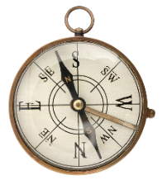  What is our school like?  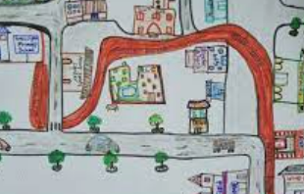 | What is the UK like?  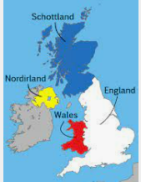 | What is our world like?  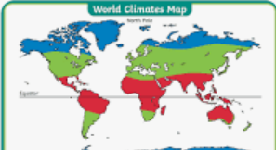
EYFS Year A | Describe their immediate environment using knowledge from observation, discussion, stories, non-fiction texts and maps. | Know some similarities and differences between different religious and cultural communities in this country, drawing on their experiences and what has been read in class. | Explain some similarities and differences between life in this country and life in other countries, drawing on knowledge from stories, non-fiction texts and (when appropriate) maps.
Lower School Year B | How do our seasons change?  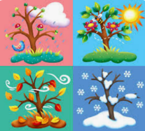 | What is it like in Salcombe?  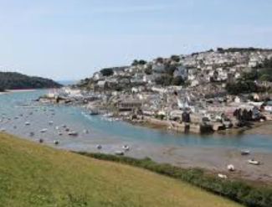 | What is it like in Cape Town?  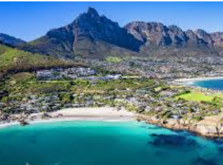
EYFS Year B | Understand some important processes and changes in the natural world around them, including the seasons and changing states of matter. | Describe their immediate environment using knowledge from observation, discussion, stories, non-fiction texts and maps. | Explain some similarities and differences between life in this country and life in other countries, drawing on knowledge from stories, non-fiction texts and (when appropriate) maps.

 | Autumn | Spring | Summer
Middle School  Year A | 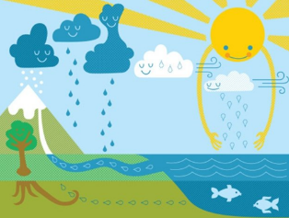  What is the water cycle? | What’s the same and what’s different between Salcombe and Mazarron, Spain?  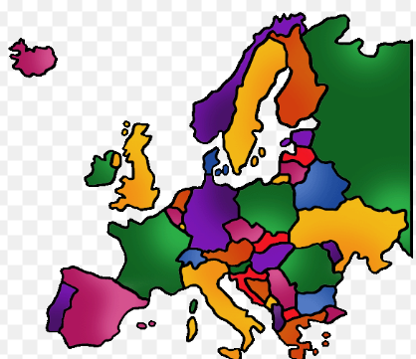 | What makes a good settlement?  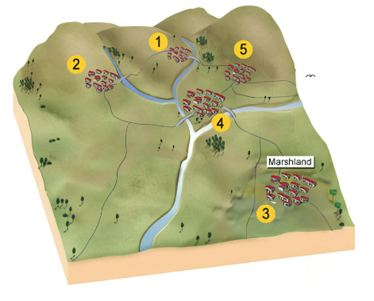
Middle School Year B | What counties do we have in England?  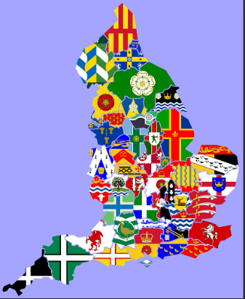 | What is Devon like?  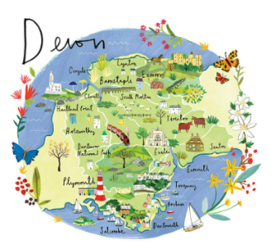 | How does tourism impact the UK?  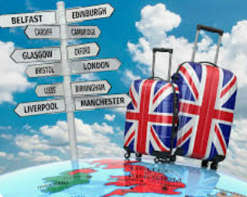
Supplementary Year | Where does our energy come from?   | Who lives in Antarctica?  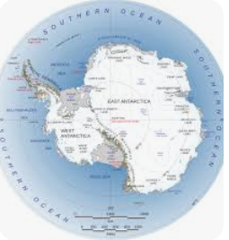 | Why are our oceans important?  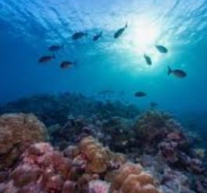

 | Autumn | Spring | Summer
Upper School  Year A | Where does our food come from? | What’s the same and what’s different between the UK and North America?  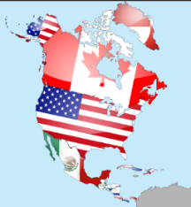 | What are our coasts like?  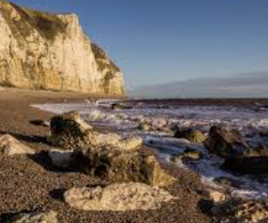
Upper School Year B | What do we know about the world?  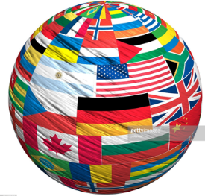 | What’s the same and what’s different between the UK and South America?  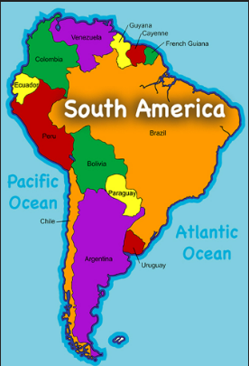 | 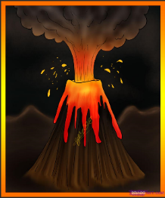  What are volcanoes?
Supplementary Year | Where does our energy come from? | Who lives in Antarctica? | Why are our oceans important?

Knowledge and Skills: Lower School Year A
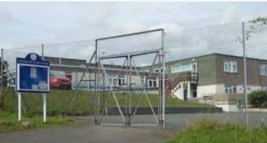  What is our school like? |  | What is the UK like? |  | What is our world like?
EYFS CURRICULUM COVERAGE:  Describe their immediate environment using knowledge from observation, discussion, stories, non-fiction texts and maps. | NATIONAL CURRICULUM COVERAGE:  KS1 – Geographical skills and fieldwork | EYFS CURRICULUM COVERAGE:  Know some similarities and differences between different religious and cultural communities in this country, drawing on their experiences and what has been read in class. | NATIONAL CURRICULUM COVERAGE:  KS1 – Locational Knowledge  KS1 – Human and physical geography | EYFS CURRICULUM COVERAGE:  Explain some similarities and differences between life in this country and life in other countries, drawing on knowledge from stories, non-fiction texts and (when appropriate) maps. | NATIONAL CURRICULUM COVERAGE:  KS1 – Locational Knowledge  KS1 – Geographical skills and fieldwork  KS1 – Human and physical geography
KS1 SUBSTANTIVE KNOWLEDGE:  I KNOW some basic geographical vocabulary to describe the location of my school: town, main road, coast, beach, shop.  I KNOW the difference between a physical feature and a human feature.  I KNOW vocabulary for key physical features – cliff, forest, hill, ocean, river.  I KNOW vocabulary for key human features – city, village, factory, farm, office, port, harbour. |  | KS1 SUBSTANTIVE KNOWLEDGE:  I KNOW the names, locations and characteristics of the four countries and capital cities of the United Kingdom.  I KNOW the surrounding seas of the United Kingdom.  I KNOW vocabulary for key physical features – cliff, forest, hill, ocean, river.  I KNOW vocabulary for key human features – city, village, factory, farm, office, port, harbour. |  | KS1 SUBSTANTIVE KNOWLEDGE:  I CAN name and locate the world’s seven continents and five oceans.  I KNOW the location of hot and cold areas of the world in relation to the Equator and the North and South Poles.
KS1 DISCIPLINARY KNOWLEDGE:  I KNOW HOW TO use locational and directional language (near and far; left, right) to describe the locations on a map.  I CAN use simple maps to recognise basic human and physical features.  I CAN devise a simple map with basic symbols in a key.  I CAN use observation skills to study the geography of my school and its grounds.  I CAN use simple fieldwork to study human and physical features of the local environment. |  | KS1 DISCIPLINARY KNOWLEDGE:  I KNOW HOW TO use atlases to identify the United Kingdom and its countries.  I KNOW HOW TO use plan perspectives/aerial photos to recognise landmarks and basic human and physical features.  I KNOW HOW TO use locational and directional language (near and far; left and right) to describe the locations on a map.  I CAN use simple maps to recognise basic human and physical features. |  | KS1 DISCIPLINARY KNOWLEDGE:  I KNOW HOW TO use world maps and globes to identify continents and oceans.  I KNOW HOW TO use locational and directional language (near and far; left and right) to describe the locations on a map.  I KNOW HOW TO use simple compass directions (North, South, East, West) to describe the location of features and routes on a map.
Knowledge and Skills: Lower School Year B
How do our seasons change? |  | What is it like in Salcombe? |  | What is it like in Cape Town?
EYFS CURRICULUM COVERAGE:  Understand some important processes and changes in the natural world around them, including the seasons and changing states of matter. | NATIONAL CURRICULUM COVERAGE:  KS1 – Human and physical geography | EYFS CURRICULUM COVERAGE:  Describe their immediate environment using knowledge from observation, discussion, stories, non-fiction texts and maps. | NATIONAL CURRICULUM COVERAGE:  KS1 – Locational Knowledge  KS1 – Human and physical geography  KS1 – Geographical skills and fieldwork | EYFS CURRICULUM COVERAGE:  Explain some similarities and differences between life in this country and life in other countries, drawing on knowledge from stories, non-fiction texts and (when appropriate) maps. | NATIONAL CURRICULUM COVERAGE:  KS1 – Human and physical geography  KS1 – Place knowledge
KS1 SUBSTANTIVE KNOWLEDGE:  I KNOW seasonal patterns in the United Kingdom.  I KNOW examples of daily weather patterns in the United Kingdom.  I KNOW vocabulary including soil, season and weather. |  | KS1 SUBSTANTIVE KNOWLEDGE:  I KNOW that Salcombe is located on the south coast of England and is in Devon.  I KNOW some physical features of Salcombe, including coastline, river, hills, harbour, beach.  I KNOW some human features of Salcombe and that is is well known for tourism and seaside holidays. |  | KS1 SUBSTANTIVE KNOWLEDGE:  I KNOW that Cape Town is a city in South Africa.  I KNOW some key human and physical features of Cape Town and it’s local area.  I KNOW some geographical similarities and differences between Salcombe and Devon, and Cape Town and the Western Cape province.
KS1 DISCIPLINARY KNOWLEDGE:  I KNOW HOW TO use simple fieldwork and observational skills to study my school, its grounds and the local environment.  I KNOW HOW TO use locational and directional language (near and far; left,right) to describe the locations on a map.  I KNOW HOW TO use simple compass directions (North, South, East, West) to describe the location of features and routes on a map.  I CAN use simple maps to recognise basic human and physical features.  I CAN devise a simple map. |  | KS1 DISCIPLINARY KNOWLEDGE:  I KNOW HOW TO use locational and directional language (near and far; left and right) to describe the locations on a map.  I CAN use observation skills to study the geography of my school and its grounds.  I CAN use aerial photographs to recognise landmarks and basic human and physical features.  I CAN devise a simple map within basic symbols in a key.  I CAN use simple fieldwork to study human and physical features of the local environment. |  | KS1 DISCIPLINARY KNOWLEDGE:  I CAN use atlases and world maps to locate the Africa, South Africa and Cape Town.  I CAN use aerial photographs to recognise human and physical features.  I KNOW HOW TO use locational and directional language (near and far; left,right) to describe the locations on a map.
Knowledge and Skills: Middle School Year A
What is the water cycle? | What’s the same and what’s different between Salcombe and Mazarron, Spain? | What makes a good settlement?
NATIONAL CURRICULUM COVERAGE:  KS2 – Human and physical geography  KS2 – Locational knowledge  KS2 – Place knowledge  KS2 – Geographical skills and fieldwork | NATIONAL CURRICULUM COVERAGE:  KS2 – Locational knowledge  KS2 – Place knowledge  KS2 – Geographical skills and fieldwork | NATIONAL CURRICULUM COVERAGE:  KS2 – Locational knowledge  KS2 – Place knowledge  KS2 – Geographical skills and fieldwork
SUBSTANTIVE KNOWLEDGE:  I KNOW and understand the water cycle.  I KNOW the physical geography of rivers.  I CAN locate some examples of key world and UK rivers on a map.  I UNDERSTAND why rivers are important.  I KNOW some causes of river pollution. | SUBSTANTIVE KNOWLEDGE:  I KNOW the location of many countries in Europe (including Russia).  I KNOW some of the major cities within European countries.  I KNOW some key physical and human characteristics of countries in Europe.  I KNOW similarities and differences between Devon in UK and a region in a European country. | SUBSTANTIVE KNOWLEDGE:  I KNOW what settlements are and different types of settlements (hamlet, village, town, city).  I KNOW some settlements have a special use or function, eg. port, market town, resort.  I KNOW that land use is either rural or urban, and that this can change over time.  I KNOW how settlement and land use relates to my part of the world.
KS2 DISCIPLINARY KNOWLEDGE:  I KNOW HOW TO use symbols and keys (including the use of Ordnance Survey maps).  I KNOW HOW TO use fieldwork to observe, measure, record and present the human and physical features in the local area using a range of methods (river or stream link). | KS2 DISCIPLINARY KNOWLEDGE:  I KNOW HOW TO use four-figure then six-figure grid references  to build my knowledge of the UK and Europe.  I KNOW HOW TO use maps, atlases and globes to locate countries and describe features studied. | DISCIPLINARY KNOWLEDGE:  I KNOW HOW TO use symbols and keys (including the use of Ordnance Survey maps).  I KNOW HOW TO use fieldwork to observe, measure, record and present the human and physical features in the local area using a range of methods (land use link).

Knowledge and Skills: Middle School Year B
What counties do we have in England? | What is it like in Devon? | How does tourism impact the UK?
NATIONAL CURRICULUM COVERAGE:  KS2 – Locational knowledge  KS2 – Human and physical geography | NATIONAL CURRICULUM COVERAGE:  KS2 – Locational knowledge  KS2 – Place knowledge  KS2 – Geographical skills and fieldwork | NATIONAL CURRICULUM COVERAGE:  KS2 – Human and physical geography  KS2 – Locational knowledge  KS2 – Geographical skills and fieldwork
SUBSTANTIVE KNOWLEDGE:  I KNOW the location of Devon and its surrounding counties.  I KNOW some of the geographical regions and counties of the United Kingdom, and their identifying human and physical characteristics.  I KNOW key topographical features of the United Kingdom, including hills, mountains, coasts and rivers. | SUBSTANTIVE KNOWLEDGE:  I KNOW the location of cities and some large towns in Devon (eg Exeter, Plymouth, Torquay, Paignton, Salcombe).  I CAN describe the varying landscape of Devon, including the two National Parks, the South and North coasts and the key rivers of the county.  I UNDERSTAND the importance and impact of agriculture in Devon. | SUBSTANTIVE KNOWLEDGE:  I KNOW the different types of holiday people go on, eg. adventure holidays, holidays of faith and eco-tourism.  I KNOW the positive impact of tourism (including economic) and the negative impact (including environmental).  I KNOW how tourism is linked to Salcombe and other local towns.
KS2 DISCIPLINARY KNOWLEDGE:  I CAN use four-figure and then six-figure grid references.  I CAN use keys and symbols, including in Ordnance Survey maps.  I KNOW HOW TO use fieldwork to observe, measure, record and present the human and physical features in the local area, eg sketch maps, plans and graphs. | KS2 DISCIPLINARY KNOWLEDGE:  I KNOW HOW TO use fieldwork to observe, measure, record and present the human and physical features in the local area, eg sketch maps, plans and graphs.  I CAN use four-figure and then six-figure grid references. | DISCIPLINARY KNOWLEDGE:  I KNOW HOW TO present and communicate my geographical ideas, including understanding different points of view/perspectives on the same idea.

Knowledge and Skills: Upper School Year A
What are volcanoes? | What’s the same and what’s different between the UK and North America? | What are our coasts like?
NATIONAL CURRICULUM COVERAGE:  KS2 – Human and physical geography  KS2 – Locational knowledge  KS2 – Geographical skills and fieldwork | NATIONAL CURRICULUM COVERAGE:  KS2 – Locational knowledge  KS2 – Place knowledge  KS2 – Geographical skills and fieldwork | NATIONAL CURRICULUM COVERAGE:  KS2 – Human and physical geography  KS2 – Locational knowledge  KS2 – Geographical skills and fieldwork
SUBSTANTIVE KNOWLEDGE:  I KNOW the position and significance of latitude and longitude, and the Tropics of Cancer and Capricorn.  I KNOW different biomes and vegetation belts, and can label some examples on a world map.  I KNOW the physical geography of mountains, volcanoes and earthquakes. | SUBSTANTIVE KNOWLEDGE:  I KNOW the location of North America, its major countries and its environmental regions, and some key physical and human characteristics.  I KNOW some similarities and differences in the physical and human geography of a region in United Kingdom and a region in North America (coasts such as South Devon compared to Florida coast). | SUBSTANTIVE KNOWLEDGE:  I KNOW that the coast is the boundary between land and sea.  I KNOW how physical processes (waves, tides, erosion, deposition) create landforms like cliffs, beaches, and dunes.  I KNOW about the human geography linked to coasts, including ports and harbours.
DISCIPLINARY KNOWLEDGE:  I KNOW HOW TO use maps, atlases and digital/computer mapping to locate countries and describe features studied.  I KNOW HOW TO use 6 figure grid references, symbols and keys to build my knowledge of the wider world. | KS2 DISCIPLINARY KNOWLEDGE:  I KNOW HOW TO use maps, atlases and digital/computer mapping to locate countries and describe features studied.  I KNOW HOW TO use 6 figure grid references, symbols and keys to build my knowledge of the wider world. | KS2 DISCIPLINARY KNOWLEDGE:  I KNOW HOW TO use fieldwork to observe, measure, record and present the human and physical features in the local area, eg sketch maps, plans and graphs.

Knowledge and Skills: Upper School Year B
What do we know about the world? | What’s the same and what’s different between the UK and South America? | Where does our food come from?  
NATIONAL CURRICULUM COVERAGE:  KS2 – Locational knowledge  KS2 – Place knowledge  KS2 – Geographical skills and fieldwork | NATIONAL CURRICULUM COVERAGE:  KS2 – Locational knowledge  KS2 – Place knowledge  KS2 – Geographical skills and fieldwork | NATIONAL CURRICULUM COVERAGE:  KS2 – Human and physical geography  KS2 – Geographical skills and fieldwork
SUBSTANTIVE KNOWLEDGE:  I KNOW the position and significance of latitude, longitude, Equator, Northern hemisphere, Southern hemisphere, the tropics of Cancer and Capricorn, Arctic and Antarctic circle.  I KNOW the position and significance of the Prime/Greenwich Meridian and time zones (including day and night).  I CAN locate the world’s countries using maps. | SUBSTANTIVE KNOWLEDGE:  I KNOW the location of South America, its major countries and its environmental regions, and some key physical and human characteristics.  I KNOW some similarities and differences in the physical and human geography of a region in United Kingdom and a region in South America (e.g. woodland management in Amazon rainforest compared to locally). | SUBSTANTIVE KNOWLEDGE:  I KNOW key aspects of economic activity such as trade links (including Fair Trade).  I CAN describe the distribution of natural resources including energy, food, minerals and water.
KS2 DISCIPLINARY KNOWLEDGE:  I KNOW HOW TO use four-figure then six-figure grid references to build my knowledge of the wider world.  I KNOW HOW TO use atlases and digital/computer mapping to locate countries and describe features studied. | KS2 DISCIPLINARY KNOWLEDGE:  I KNOW HOW TO use maps, atlases and digital/computer mapping to locate countries and describe features studied.  I KNOW HOW TO use four-figure then six-figure grid references, symbols and keys to build my knowledge of the wider world. | DISCIPLINARY KNOWLEDGE:  I CAN use fieldwork to observe, measure, record and present the human and physical features in the local area using a range of methods. (Example questions = Do we import more food from the rest of the world than we grow? What impact does trade with other countries have on our area?)

Knowledge and Skills: Supplementary Year
Where does our energy come from? | Who lives in Antarctica? | Why are our oceans important?
NATIONAL CURRICULUM COVERAGE:  KS2 – Human and physical geography | NATIONAL CURRICULUM COVERAGE:  KS2 – Human and physical geography | NATIONAL CURRICULUM COVERAGE:  KS2 – Human and physical geography
SUBSTANTIVE KNOWLEDGE:  I KNOW why energy is important.  I KNOW the difference between renewable and non-renewable energy and how this relates to climate change.  I KNOW how natural resources are distributed globally. | SUBSTANTIVE KNOWLEDGE:  I CAN locate Antarctica on a map and understand how it’s position links to its climate zone and biome.  I KNOW what is meant by an expedition, and how Antarctica was explored by Shackleton.  I KNOW about patterns of daylight in the Antarctic circle. | SUBSTANTIVE KNOWLEDGE:  I KNOW about Roman and Anglo-Saxon laws and justice.  I KNOW how the Tudors punished criminals.  I KNOW what a Highwayman was and how they can be seen as heroes or villains.  I KNOW how what Victorian prisons were like.
DISCIPLINARY KNOWLEDGE:  I CAN use fieldwork to observe, measure, record and present the human and physical features in the local area using a range of methods. (eg sketch maps, design and plan an enquiry into solar panels) | DISCIPLINARY KNOWLEDGE:  I KNOW and sequence key events of the time studied. (Chronological Understanding)  I CAN place current study on timeline in relation to other studies. (Chronological Understanding)  I CAN examine causes and results of key events and the impact on people. (Range & Depth of Knowledge) | DISCIPLINARY KNOWLEDGE:  I CAN place the time studied and key events from time on a timeline. (Chronological Understanding)  I CAN compare an aspect of life with the same aspect in another period. (Range and Depth of Historical Understanding)  I CAN identify and give reasons for different ways in which the past is represented. (Interpretations of History)

Progression by Disciplinary Knowledge
Progression by Disciplinary Skill
 | Lower School | Middle School | Upper School
Human and Physical Geography | - Identify seasonal and daily weather patterns in the United Kingdom.  - Use basic geographical vocabulary for key physical features: beach, cliff, coast, forest, hill, mountain, sea, ocean, river, valley, soil, vegetation, season, weather.  - Use basic geographical vocabulary for key human features: city, town, village, factory, farm, house, port, office, harbour, shop.  - Know the location of hot and cold areas of the world in relation to the Equator and the North and South poles. | - Describe and understand the physical geography of climate zones.  - Understand the water cycle.  - Describe and understand key aspects of rivers.  - Describe and understand aspects of human geography, including types of settlement and land use. | - Describe and understand the physical geography of biomes and vegetation belts.  - Describe and understand the physical geography of mountains, volcanoes and earthquakes.  - Understand aspects of human geography, including economic activity and trade links, the distribution of natural resources (eg energy, food, minerals and water).
Locational Knowledge | - Name, locate and identify characteristics of the 4 countries and capital cities of the United Kingdom, and its surrounding seas.  - Name and locate the world’s seven continents and five oceans. | - Name and locate counties and cities of the UK, geographical regions and their human and physical characteristics, key topographical features (inc hills, mountains, coasts and rivers), and land use patterns; understand how some of these have changed over time.  - Locate countries in Europe (including Russia) using maps, including their key physical and human characteristics, and major cities. | - Locate countries in North and South America using maps, including their environmental regions, key physical and human characteristics, and major cities.  - Identify the position and significance of the Equator, Northern hemisphere, Southern hemisphere, Arctic and Antarctic circles, latitude, longitude, the Tropics of Cancer and Capricorn.  - Identify the position and significance of the Prime/Greenwich Meridian and time zones (including day and night).
 | Lower School | Middle School | Upper School
Place Knowledge | - I am beginning to understand geographical similarities and differences through studying the human and physical geography of a small area of the UK, and a small area of a contrasting African country. | - I understand geographical similarities and differences through studying the human and physical geography of a region of the UK and a region in a European country. | - I understand geographical similarities and differences through studying the human and physical geography of a region of the UK and regions within North and South America.
Geographical Skills and Fieldwork | - Use aerial photographs to recognise basic human and physical features, and recognise landmarks.  - Use simple fieldwork and observational skills to study the geography of my school, its grounds and the local environment.  - Use an atlas to identify the United Kingdom and its countries.  - Use world maps, atlases and globes to identify the UK and Africa.  - Use locational and directional language (near and far; left and right) to describe locations on a map.  - Use plan perspectives to recognise basic human and physical features.  - Use simple compass directions (North, South, East, West) to describe the location of features, and routes on a map.  - Devise a simple map.  - Use and construct basic symbols in a key. | - Use fieldwork to observe and record the human and physical features in the local area using a range of methods, including sketch maps, plans and graphs.  - Use maps, globes and atlases to locate the areas and features studied.  - Use the eight points of a compass to build my knowledge of the UK.  - Use symbols and keys (including on Ordnance Survey maps).  - Use four-figure grid references to build my knowledge of UK and Europe. | - Use fieldwork to observe, measure and record the human and physical features in the local area using a range of methods, including sketch maps, plans and graphs, and digital technologies.  - Use digital/ computer mapping to locate countries and describe features studied.  - Use six-figure grid references to build my knowledge of the wider world.

Geography for learners with SEND
Inclusion in geography means: setting suitable learning challenges, responding to pupils’ diverse needs, and overcoming potential barriers to learning and assessment for individuals and groups.
Possible struggle or challenge | Scaffold or support to consider
- Difficulties with reading | - Pairing of confident and less confident readers when considering groupings in geography.  - Make frequent use of audio/visual stimuli about places and features. Pictures/drawings/recordings/video clips can be used to generate pupil-to-pupil discussion or precede written information. Use or present information in tables or diagrams, rather than unbroken text.  - Make use of fluency strategies from reading lessons when reading geographical information – including echo reading and choral reading.
- Difficulties with language/ vocabulary | - Provide a word bank related to the theme. This could be provided before the start of the unit, as pre-teaching, or built up cumulatively throughout the sequence of lessons.  - Provide sentence stems/speaking frames for oracy/discussion tasks to structure spoken language.  - Recognise that the language of history may be challenging and cause barriers for some pupils, including the use of geography-specific terms, eg ‘biome’, ‘meander’. Plan to teach new geography vocabulary explicitly in context using activities from the menu of instructional activities.  - Use pictures and symbols (eg Widgit) to illustrate new geographical concepts.  - Simplify questioning words – for example, do not ask them to ‘compare and contrast’ but ask ‘what are the things that are different between …’
- Difficulties with writing/ recording | - Consider alternatives to written recording at times. Children may be able to achieve more verbally than in written form, so involve them fully in showing their learning through discussions, drama and debates.
- Difficulties with maths/number | - Be aware of challenges with shape and space potentially being a barrier in map/compass work. Increase adult support, or make use of mixed ability pairings, where possible.  - Ensure large numbers used in geographical learning (eg population or area of a country) can be read and understood by the child, in order to have meaning.
- Difficulties with memory/ processing | - Use a digital camera to capture important findings on a field trip for future reference. Images can also be used to build a visual record. Simple audio recorders can be used instead of written notes during visits or field trips.  - Reinforcement of key facts eg locations of places on a map, through retrieval practice principles – revisit regularly, spaced practice, dual coding (words and visuals together).  - Reduce reliance on memory by using a chart that shows the ‘big picture’ to help pupils make links between lessons, eg a chart showing the big question, and how each lesson is related to the question. Use mind maps and other visual devices to help pupils see patterns and relationships.  - Narrative can help all pupils, including those with learning difficulties, to make sense of events by bringing other countries and cultures to life, so consider using stories (of real people living in different parts of the world) within geography learning.  - When questioning, allow pupils time to discuss the answers to questions in pairs, before requesting verbal responses. Structures such as think-pair-share can be really helpful.  - When you are asking questions, use pupils’ names to warn them that they are about to be involved. Sometimes, warning pupils quietly that you are about to ask them a question gives them a little thinking time and they may be able to answer more confidently.  - Invite pupils to comment on a key issue, and check their understanding by asking them to reformulate it in their own words or in a different form. For example, after an enquiry about tectonic processes, ask pupils to explain their findings in diagrams, as well as explaining orally or in writing.
- Difficulties with engagement, for example because of SEMH needs | - Identify pupils’ existing geographical knowledge and prior experience eg using posters, concept maps and mind-mapping software.  - Relate geographical concepts to everyday applications. Use real objects as a starting point for developing the concepts and the language needed to describe and discuss what pupils have observed or experienced.  - Concrete materials and sensory resources, such as a replica rainforest, can help pupils understand unfamiliar locations and people

